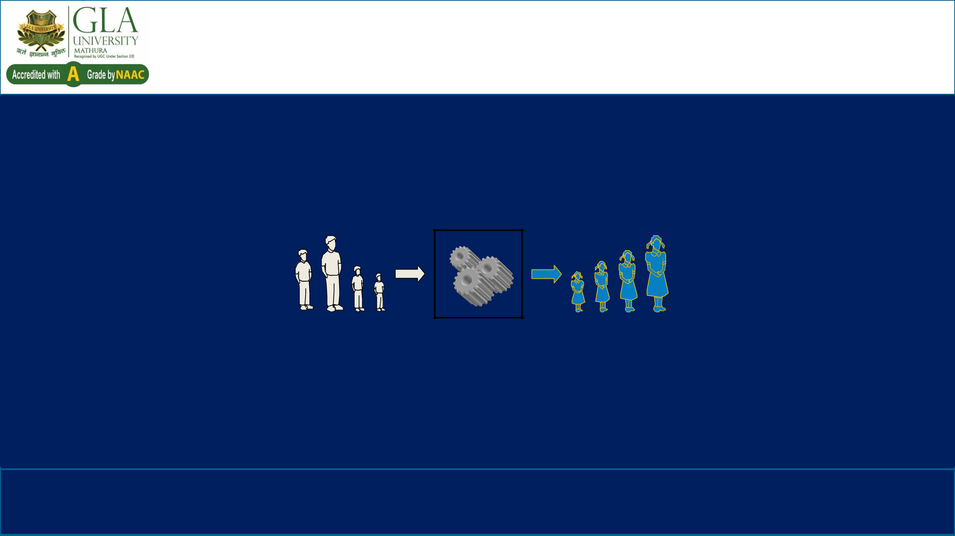
DESIGN & ANALYSIS OF ALGORITHM

(BCSC0012)

Chapter 12: Dynamic Programming

Chained Matrix Multiplications

Input Algorithm Output

Prof. Anand Singh Jalal

Department of Computer Engineering & Applications

 Chained Matrix Multiplications
Problem: given a sequence ⟨A₁, A₂, …, A_{n}⟩, compute the product:
A₁ ⋅ A₂ ⋅⋅⋅ A_{n}

- Matrix compatibility:
C=A⋅B | C=A₁ ⋅ A₂ ⋅⋅⋅ A_{i} ⋅ A_{i+1} ⋅⋅⋅ A_{n}
col_{A} = row_{B} | col_{i} = row_{i+1}
row_{C} = row_{A} | row_{C} = row_{A1}
col_{C} = col_{B} | col_{C} = col_{An}
Algorithm to Multiply 2 Matrices

Input: Matrices A_{p×q} and B_{q×r} (with dimensions p×q and q×r)
Result: Matrix C_{p×r} resulting from the product A·B

MATRIX-MULTIPLY(A_{p×q} , B_{q×r})

- for i ← 1 to p

2. | for j ← 1 to r
3. | C[i, j] ← 0
4. | for k ← 1 to q
5. | C[i, j] ← C[i, j] + A[i, k] · B[k, j]

- return C

Scalar multiplication in line 5 dominates time to compute CNumber of scalar multiplications = pqr

Matrix-chain Multiplication

  - Suppose we have a sequence or chain A1, A2, …, An of n matrices to be multiplied

  - That is, we want to compute the product A1A2…An

  - There are many possible ways (parenthesizations) to compute the product

- Example: consider the chain A₁, A₂, A₃, A₄ of 4 matrices

– Let us compute the product A₁A₂A₃A₄

- There are 5 possible ways:
1. | (A₁(A₂(A₃A₄))) |  | 1 | 2(n−1)_{C}
2. | (A₁((A₂A₃)A₄)) | No of possible ways: | 1 | 2(n−1)_{C}
3. | ((A₁A₂)(A₃A₄)) |  | n | ( n−1)
- ((A₁(A₂A₃))A₄)

- (((A₁A₂)A₃)A₄)

Matrix-chain Multiplication …

- Example: Consider three matrices A_{10×100}, B_{100×5}, and

^{C}5×50
- There are 2 ways to parenthesize
– ((AB)C) = D_{10×5} · C_{5×50}

• | AB ⇒ 10·100·5=5,000 scalar multiplications | Total:
• | DC ⇒ 10·5·50 =2,500 scalar multiplications | 7,500
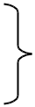
– (A(BC)) = A_{10×100} · E_{100×50}

• | BC ⇒ 100·5·50=25,000 scalar multiplications | Total:
• | AE ⇒ 10·100·50 =50,000 scalar multiplications | 75,000
Matrix-chain Multiplication …

- Matrix-chain multiplication problem
– Given a chain A₁, A₂, …, A_{n} of n matrices, where for i=1, 2, …, n, matrix A_{i} has dimension p_{i-1}×p_{i}

– Parenthesize the product A₁A₂…A_{n} such that the total number of scalar multiplications is minimized

- Brute force method of exhaustive search takes time exponential in n

A₁ ⋅ | A₂ ⋅⋅⋅ | A_{i} ⋅ | A_{i+1} ⋅⋅⋅ | A_{n}
p₀ x p₁ | p₁ x p₂ | ^{p}i-1 ^{x p}i | ^{p}i ^{x p}i+1 | ^{p}n-1 ^{x p}n

Matrix-chain Multiplication …

The Structure of an Optimal Parenthesization

- Notation:
A_{i…j} = A_{i} A_{i+1} ⋅⋅⋅ A_{j}, i ≤ j
- Suppose that an optimal parenthesization of A_{i…j} splits the product

A_{k} and A_{k+1}, wherei ≤ k < jbetween
Ai…j = Ai Ai+1 ⋅⋅⋅ Aj
- A_{i} A_{i+1} ⋅⋅⋅ A_{k} A_{k+1} ⋅⋅⋅ A_{j}
- Ai…k Ak+1…j

The parenthesization of the “prefix” A_{i…k} must be an optimal parentesization

Matrix-chain Multiplication …
A Recursive Solution

- Sub-problem: Determine the minimum cost of parenthesizing
A_{i…j} = A_{i} A_{i+1} ⋅⋅⋅ A_{j} for 1 ≤ i ≤ j ≤ n

- Let m[i, j] = the minimum number of multiplications needed to compute A_{i…j}

– full problem (A_{1..n}): m[1, n]

– i = j: Ai…i = Ai ⇒ m[i, i] = 0, for i = 1, 2, …, n

Matrix-chain Multiplication …
A Recursive Solution

- Consider the subproblem of parenthesizing

A_{i…j} = A_{i} A_{i+1} ⋅⋅⋅ A_{j} |  | for 1 ≤ i ≤ j ≤ n
⁼ Ai…k Ak+1…j | ^{p}i-1^{p}k^{p}j | for i ≤ k < j
m[i, k] | m[k+1,j]
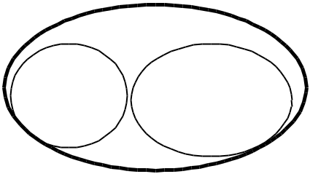
- Assume that the optimal parenthesization splits the product A_{i} A_{i+1} ⋅⋅⋅
A_{j} at k (i ≤ k < j)

m[i, j] = m[i, k] + m[k+1, j] + p_{i-1}p_{k}p_{j}

min # of multiplications | min # of multiplications | # of multiplications
to compute A_{i…k} | to compute A_{k+1…j} | to compute A_{i…k}A_{k…j}

Matrix-chain Multiplication …
A Recursive Solution

m[i, j] = m[i, k] + m[k+1, j] + p_{i-1}p_{k}p_{j}

- We do not know the value of k

– There are j – i possible values for k: k = i, i+1, …, j-1
• Minimizing the cost of parenthesizing the product A_{i} A_{i+1} ⋅⋅⋅ A_{j} becomes:

0 if i = j

m[i, j] = min {m[i, k] + m[k+1, j] + p_{i-1}p_{k}p_{j}} if i < j
i≤k<j
Matrix-chain Multiplication …
Matrix-Chain-Order(p)
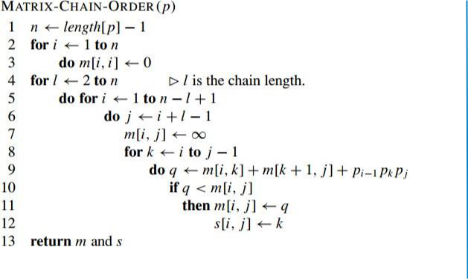

There are 3 nested loops and each can iterate at most n times, so the total running time is O(n3).

Basically, we’re checking different places to “split” our matrices by checking different values of k and seeing if they improve our current minimum value.

Matrix-chain Multiplication …
Extracting Optimum Sequence

- Leave a split marker indicating where the best split is (i.e. the value of k leading to minimum values of m[i, j]). We maintain a parallel array s[i, j] in which we store the value of k providing the optimal split.

- If s[i, j] = k, the best way to multiply the sub-chain A_{i…j} is to first multiply
the sub-chain A_{i…k} and then the sub-chain A_{k+1…j} , and finally multiply them
together. Intuitively s[i, j] tells us what multiplication to perform last.
We only need to store s[i, j] if we have at least 2 matrices & j > i.
Matrix-chain Multiplication …
Example: DP for CMM
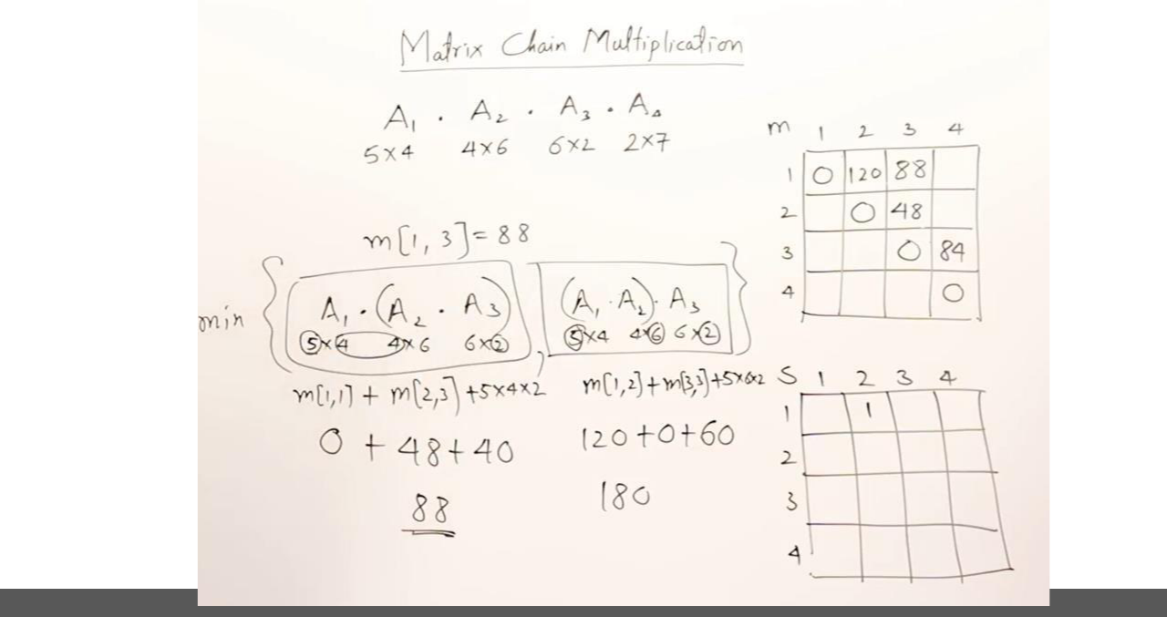
Matrix-chain Multiplication …
Example: DP for CMM
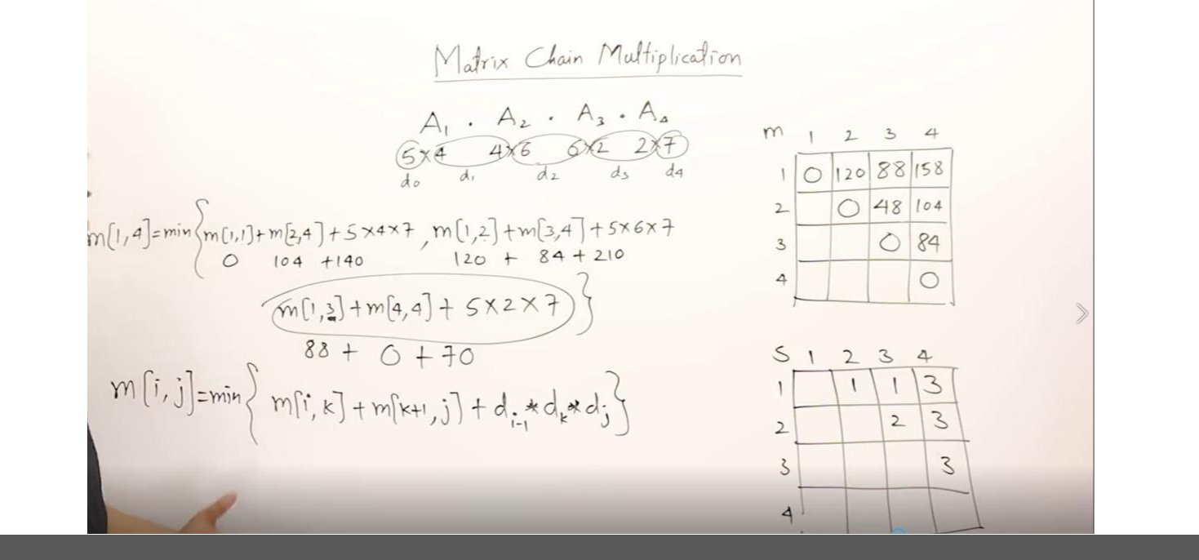
Matrix-chain Multiplication …
Example: DP for CMM

- The initial set of dimensions are <5, 4, 6, 2, 7>: we are multiplying A₁ (5x4) times A₂ (4x6) times A₃ (6x2) times A₄ (2x7). Optimal sequence is

(A₁ (A₂A₃ )) A₄.
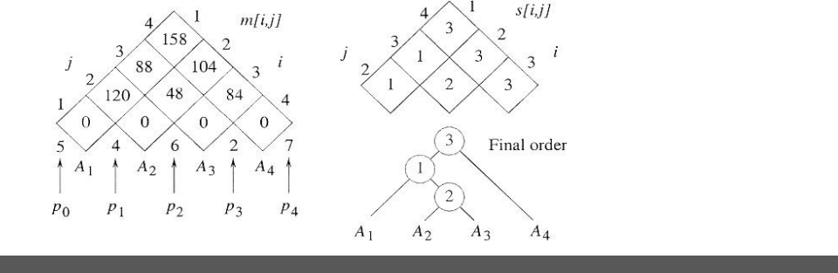


Any Questions ?

Dr. Anand Singh Jalal

Professor

Email: asjalal@gla.ac.in

